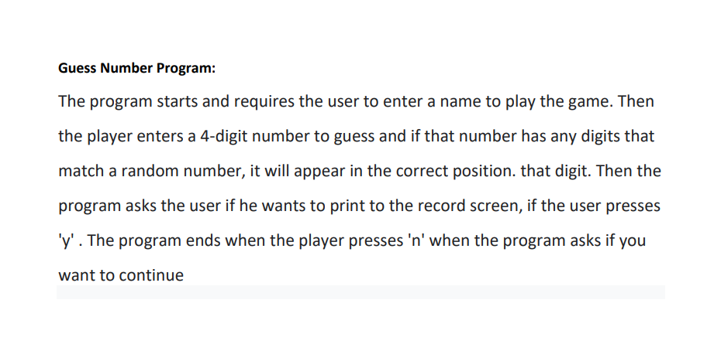

#include <stdio.h>

#include <stdlib.h>

#include <time.h>

#include <string.h>

struct nguoichoi

{

    char ten[24];

    int solandoan;

};

struct nguoichoi playerarray[100]; //initializize struct nguoichoi have 100 element

int count = 0;

struct nguoichoi player;

int taosongaunhien() //initializize random number

{

    srand(time(NULL));

    int randomNumber = rand() % 9000 + 1000;

    return randomNumber;

}

void swap(struct nguoichoi *a, struct nguoichoi *b) {  // swap address struct

    struct nguoichoi temp = *a;

    *a = *b;

    *b = temp;

}

void sosanhketqua(int number[], int *arr, int *arrrd)

{

    for (int i = 0; i < 4; i++)

    {

        if (number[i] == arrrd[i])

        {

            arr[i] = arrrd[i];

        }

    }

}

void tachSo(int numberrandom, int *arr)

{  // seperate number into array

    arr[0] = numberrandom / 1000;

    arr[1] = (numberrandom / 100) % 10;

    arr[2] = (numberrandom / 10) % 10;

    arr[3] = numberrandom % 10;

}

void loaddata() {

    FILE *file = fopen("danhsach.txt", "r");

    if (file == NULL) {

        printf("can't open file.\n");

        exit(1);

    }

    count=0;

    while (fscanf(file, "%s %d", playerarray[count].ten, &playerarray[count].solandoan) == 2)

    {

        count++;                            // Go through each element in the file and count element

    }

    fclose(file);

}

void luuvaofilevathem() {

    FILE *file = fopen("danhsach.txt", "w"); // open file "danhsach.txt" "with writing mode

    if (file == NULL) {

        printf("can't open file.\n");

        exit(1);

    }

    if(count<100)

    {

    playerarray[count] = player;

    count++;

    for (int i = 0; i < count; i++) {            // arrange element base on total guesses

        for (int j = 0; j < count - i - 1; j++) {

            if (playerarray[j].solandoan > playerarray[j + 1].solandoan) {

                swap(&playerarray[j], &playerarray[j + 1]);

            }

        }

    }

    // write player's data to file

    if (count == 0) {

        fprintf(file, "%s %d\n", playerarray[0].ten, playerarray[0].solandoan);

    }

    else {

            for (int i = 0; i < count; i++)

                {

                    fprintf(file, "%s %d\n", playerarray[i].ten, playerarray[i].solandoan);

                }

        }

    }

    fclose(file);

}

void inrakyluc()

{   // print top five data after arrange from file

    printf("TOP 5 record:\n");

    if(count >5)

    {

        for (int i = 0; i < 5; i++)

        {

             float ti_le_doan = (float) 1 / playerarray[i].solandoan * 100;

            printf("record %d *****user name: %s \n total number of guesses: %d\n lucky ratio: %.2f%%\n", i + 1, playerarray[i].ten, playerarray[i].solandoan, ti_le_doan);

        }

    }

    else if(count<=5)

    {

        for (int i = 0; i < count; i++)

        {

             float ti_le_doan = (float) 1 / playerarray[i].solandoan * 100;

printf("Record %d *****\n user name: %s\n total number of guesses: %d\n lucky ratio: %.2f%%\n", i + 1, playerarray[i].ten, playerarray[i].solandoan, ti_le_doan);

        }

    }

}

void inraketqua(int *arr, int *arrrd)

{

    // compare randomNumber and number which user enters

    int array[4]={-1, -1, -1, -1};

    {

        for (int i = 0; i < 4; i++)

        {

            if (arr[i] == arrrd[i])

                {

                    array[i] = arrrd[i];

                }

        }

    }

     for (int i = 0; i < 4; i++)

     {

            if (array[i] != -1) {

                printf("%d", array[i]);

            }

            else {

printf("_");

            }

    }

        printf("\n");

}

int main() {

    int dem = 0;

    int arrrd[4];

    int arr[4];

    char key;

    printf("START GAME !!!!!!!\n");

    do {

        // request user enter input to play a game

        char name[24];

        printf("enter your name: ");

        fgets(name, sizeof(name), stdin);

        int randomNumber = taosongaunhien();

        printf("random number is: %d\n", randomNumber);

        int number;

        nhap:

        while(number != randomNumber) {

            printf("enter your number(4 digit): ");

            scanf("%d", &number);

            if (number < 1000 || number > 9999 ) {

                printf("Invalid value, please enter a 4-digit number.\n");

                continue;

            }

            dem++;

            tachSo(randomNumber, arrrd);

            tachSo(number, arr);

            inraketqua(arr, arrrd);

            printf("Total guesses: %d\n", dem);

        }

        // assign value to struct and print record

        strcpy(player.ten, name);

        player.solandoan = dem;

        loaddata();

        luuvaofilevathem();

        printf("Do you wanna see the record (y/n)");

        char k;

        scanf(" %c",&k);

        if(k=='y')

           {

               inrakyluc();

           }

        else;

        // Ask the user if he wants to continue playing

        printf("Do you want to play again? (y/n): ");

        scanf(" %c", &key);

        getchar();

        dem = 0;

    } while (key == 'y');

    printf("END GAME !!!");

    return 0;

}